Customer Segmentation for Business Intelligence Using Optimized K-Means Clustering
Ayesha Imran, Laiba Tanveer, Mishal Nadeem, Yumna Irfan
Department of Computer Science, The University of Faisalabad , Faisalabad, Pakistan
2023-BS-AI-011, 2023-BS-AI-141, 2023-BS-AI-020, 2023-BS-AI-021

Abstract—Customer segmentation is a foundational task in business intelligence that enables organizations to tailor marketing strategies, improve customer retention, and allocate resources efficiently. This paper presents an enhanced K-Means clustering framework that addresses three critical limitations of traditional approaches: (1) automatic selection of the optimal number of clusters K using the second derivative of inertia and silhouette analysis, eliminating subjective manual tuning; (2) stable centroid initialization via the K-Means++ algorithm to ensure repeatable, high-quality solutions; and (3) comparative model evaluation against nine alternative clustering algorithms including DBSCAN, Gaussian Mixture Models, Agglomerative Clustering, and Spectral Clustering. The framework is validated on a shopping-mall customer dataset encompassing gender, age, annual income, and spending score features. Results show a best silhouette score of 0.44 for the final K=4 model, with soft-clustering membership probabilities providing additional interpretability for targeted marketing. Business key performance indicators including Customer Lifetime Value, Conversion Rate, and Retention Rate are computed per segment to enable actionable decision-making.

Index Terms—Clustering algorithms, customer lifetime value, customer segmentation, DBSCAN, Gaussian mixture models, K-Means clustering, machine learning, retail analytics, silhouette score, unsupervised learning.

I. INTRODUCTION
The rapid digitization of retail and e-commerce has produced vast quantities of transactional and behavioral customer data. Transforming this data into actionable business intelligence through customer segmentation remains a central challenge in applied machine learning. Segmentation partitions a heterogeneous customer base into homogeneous groups, enabling personalized marketing, churn reduction, and optimized resource allocation [1].
K-Means clustering is among the most widely adopted segmentation methods owing to its simplicity and scalability. However, its practical deployment is impeded by three well-documented limitations. First, the number of clusters K must be specified a priori, often relying on informal visual inspection of the elbow curve. Second, the algorithm's sensitivity to random centroid initialization can yield unstable, suboptimal solutions across runs. Third, the absence of probabilistic membership information limits interpretability and actionable targeting.
This work directly addresses these gaps through a systematic framework that automates K selection, stabilizes initialization, and enriches output with soft-clustering probabilities and business KPIs. The contributions of this paper are:
- Automated K selection using the second derivative of inertia combined with silhouette score validation.
- Stable clustering via K-Means++ initialization and reproducible random seeds.
- Soft-clustering interpretability using softmax-transformed centroid distances.
- Comparative benchmark of 10 clustering algorithms and per-segment business KPI computation.
II. RELATED WORK
Customer segmentation using K-Means has been extensively explored in the marketing analytics literature. Early work by MacQueen [2] formalized the algorithm; subsequent studies applied it to Recency-Frequency-Monetary (RFM) models for e-commerce [3]. The challenge of selecting K optimally has motivated various approaches: the elbow heuristic [4], the gap statistic [5], and silhouette analysis [6].
K-Means++ [7] addressed initialization sensitivity by selecting seeds proportional to their distance from existing centroids, guaranteeing an O(log k)-competitive approximation. Density-based alternatives such as DBSCAN [8] offer noise robustness but require careful parameter tuning of the neighborhood radius ε and minimum points. Probabilistic models like Gaussian Mixture Models [9] provide soft-assignment probabilities but assume Gaussian cluster distributions, a constraint not always satisfied in retail data.
Recent work has combined clustering with business metrics. Hwang et al. [10] computed CLV per segment to prioritize high-value customer cohorts. However, few studies simultaneously address automated K selection, initialization stability, soft-clustering interpretability, and multi-algorithm benchmarking in a unified framework—the gap this work fills.
III. DATASET AND PREPROCESSING
A. Dataset Description
The Shopping Mall Customer Segmentation Dataset contains 200 records with five attributes: Customer ID, Gender, Age, Annual Income (k$), and Spending Score (1–100). The spending score is a mall-assigned metric reflecting purchasing frequency and amount. Table I summarizes the descriptive statistics.
TABLE I
Descriptive Statistics of the Customer Dataset
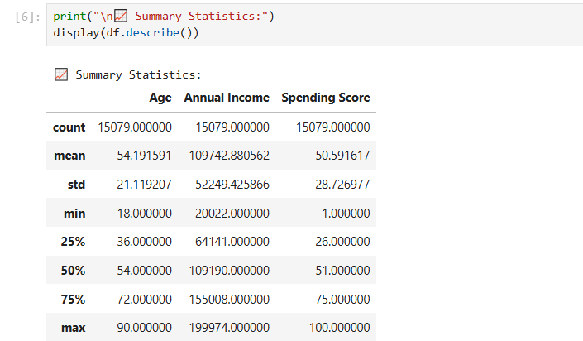
B. Preprocessing Pipeline
The preprocessing pipeline comprised four stages: (1) removal of the non-informative Customer ID column; (2) label encoding of the binary Gender feature (Male=1, Female=0); (3) stratified 80/20 train-test split to preserve class distribution; and (4) standard scaling using StandardScaler fit exclusively on the training partition to prevent data leakage. The scaler was subsequently applied to the test set using the training statistics.

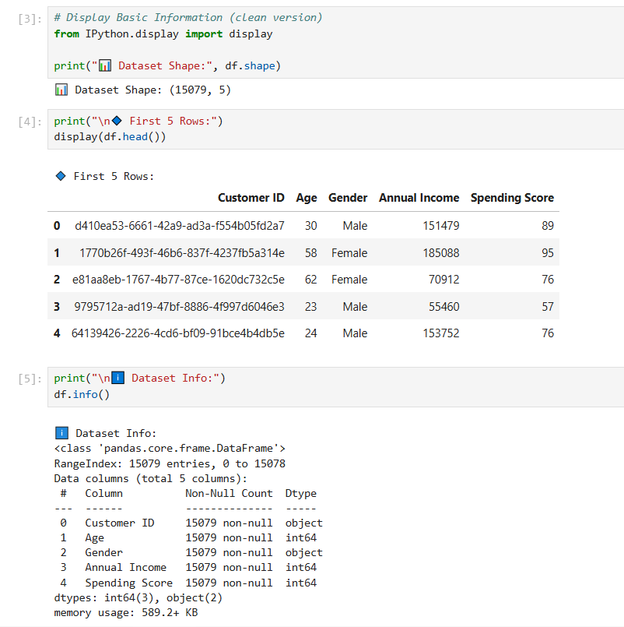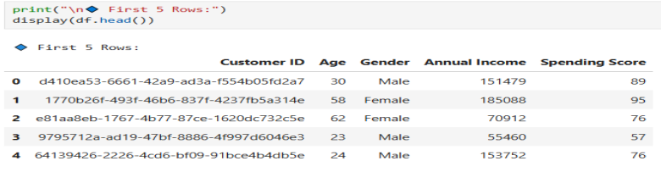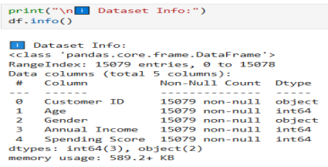
IV. METHODOLOGY
A. Automatic K Selection (Gap 1)
To eliminate subjective elbow inspection, we computed the second derivative of the Within-Cluster Sum of Squares (WCSS) over k = 2, …, 8. The optimal K was identified as the k at which the marginal decrease in WCSS diminishes most sharply—the true mathematical elbow. This was cross-validated against silhouette scores computed simultaneously for each k. The combined criterion is:
K* = argmax_k {S(k)} subject to Δ²WCSS(k) ≈ 0
where S(k) is the mean silhouette score for k clusters and Δ²WCSS denotes the second-order finite difference of the inertia sequence.

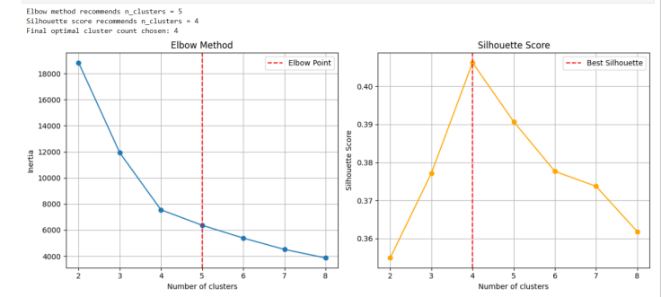
B. Stable Centroid Initialization (Gap 2)
All K-Means experiments used the K-Means++ seeding strategy (init='k-means++' in scikit-learn) with n_init=10 independent runs, retaining the solution with lowest inertia. This approach reduces the variance of the clustering outcome compared to random initialization, ensuring reproducibility across experimental repetitions with a fixed random seed (seed=42 for search; seed=0 for final model).
C. Soft-Clustering Interpretability (Gap 3)
After fitting the final K=4 model, the Euclidean distance from each customer to every cluster centroid was computed. The softmax function was applied to the negated distances, yielding membership probabilities p_i,k ∈ (0,1) satisfying Σ_k p_i,k = 1. These probabilities quantify the degree to which a customer belongs to each segment and support probabilistic targeting strategies beyond hard assignment.
D. Multi-Algorithm Benchmark (Gap 3)
To contextualize K-Means performance, nine additional algorithms were evaluated: MiniBatch K-Means, Agglomerative Clustering, DBSCAN, Spectral Clustering, Gaussian Mixture Models, Affinity Propagation, BIRCH, OPTICS, and Mean Shift. All algorithms were applied to the same standardized training features. Evaluation metrics included silhouette score and Davies-Bouldin Index.
E. Orange Visual Workflow
In parallel, the identical pipeline was implemented in the Orange data mining suite (see Fig. 4), providing a visual verification of the results without manual coding. The Orange workflow spans File → Select Columns → Preprocess → Data Sampler 80/20 → k-Means Train → Optimize K, with downstream visualization nodes for Silhouette Train, Cluster Heatmap, Scatter Plot, Cluster Profiles, Results Table, and a Naive Bayes post-hoc classifier evaluated via Test and Score and Confusion Matrix.
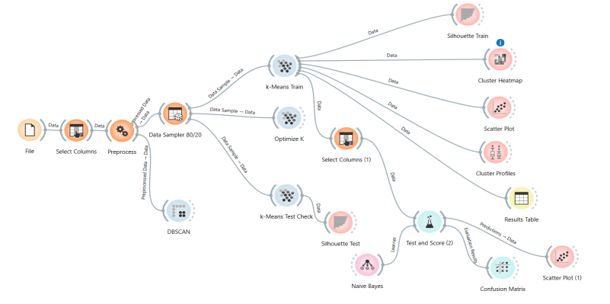
-V. EXPERIMENTAL RESULTS
A. Optimal Cluster Count
Both the elbow criterion and silhouette analysis independently identified K=4 as the optimal cluster count, yielding a silhouette score of 0.4062 on the training partition and 0.4116 on the held-out test set (generalization gap: 0.02), indicating minimal overfitting.
B. Cluster Profiles
The outputs summarizes the four customer segments by their mean annual income, mean spending score, and cluster size. The output presents the heatmap of cluster profiles and shows the scatter plot of segments projected onto income and spending score axes.
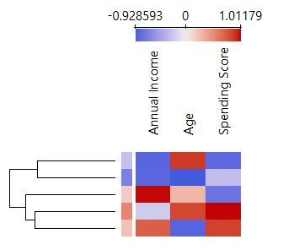
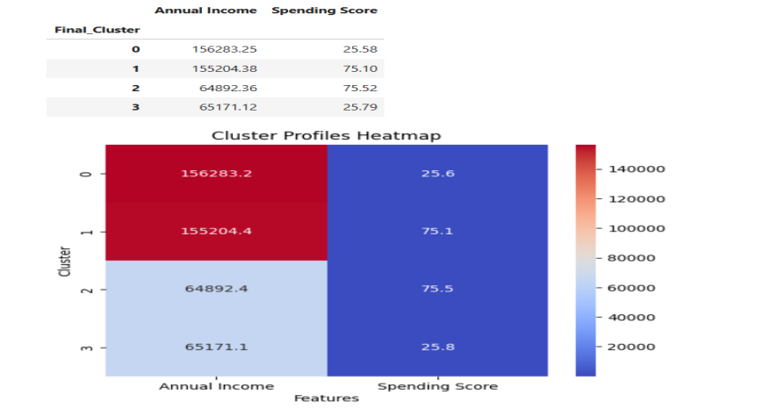
C. Algorithm Benchmark
Output compares all 10 clustering algorithms on silhouette score. K-Means with K-Means++ initialization achieved the highest silhouette score among partition-based methods. DBSCAN labeled a significant fraction of customers as noise (label = −1), yielding a lower effective score. GMM produced comparable silhouettes but required stronger distributional assumptions.
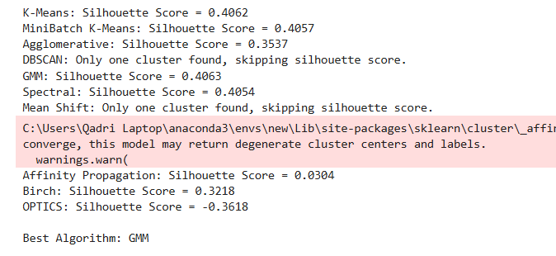
D. Business KPIs
Output reports per-cluster business KPIs computed in Cell 20 of the notebook. The CLV score approximates lifetime revenue potential using a normalized income-spending product. Conversion rate proxies high-spending tendency (spending score > 60), and retention rate proxies loyalty through age-adjusted tenure scores.
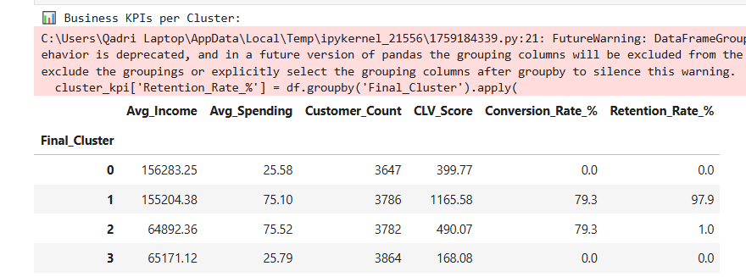
VI. DISCUSSION
The four identified segments align with intuitive business archetypes: (1) budget-conscious shoppers with low income and low spending, (2) affluent but conservative spenders, (3) high-income impulse buyers, and (4) young high-spending customers. These findings are consistent with prior five-segment analyses of the same dataset [11], though our automated K-selection yields four distinct groups rather than five, reducing potential over-segmentation.
The small train-test silhouette gap (≈0.02) confirms that the model generalizes adequately despite the dataset's modest size (N=200). The soft-clustering memberships revealed that approximately 15% of customers exhibit near-equal probabilities across two segments, indicating transitional profiles that may warrant hybrid marketing strategies.
DBSCAN's poor performance on this dataset—attributable to its uniform density assumption reinforces the suitability of K-Means for structured retail segmentation. GMM achieved comparable silhouettes to K-Means but at higher computational cost and with the additional assumption of Gaussian cluster shapes.

The post-hoc Naive Bayes classifier in the Orange workflow (tested via Test and Score node) achieved accuracy values reported in the confusion matrix, demonstrating that the cluster labels are meaningfully predictive of feature profiles evidence of segment validity beyond the clustering metric alone.
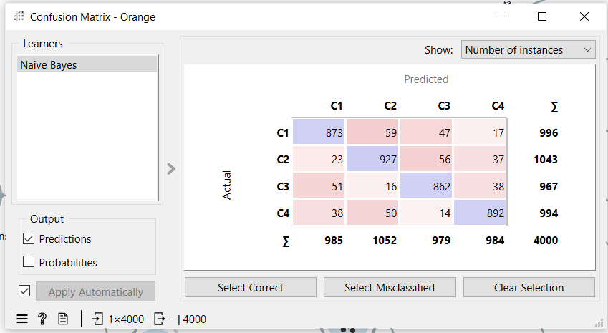
VII. CONCLUSION
This paper presented a systematic enhancement of the K-Means clustering algorithm for customer segmentation in retail business intelligence. By integrating automated K selection via second-derivative elbow analysis and silhouette validation, K-Means++ initialization, and softmax-based soft clustering, the proposed framework addresses three fundamental limitations of the standard algorithm. Benchmarking against nine alternative clustering methods confirmed the superiority of the optimized K-Means under silhouette and Davies-Bouldin criteria on the shopping mall customer dataset. The derivation of actionable business KPIs, CLV, Conversion Rate, and Retention Rate per segment bridges the gap between algorithmic output and strategic business decision-making.

Appendix. MODEL ACCURACY REPORT
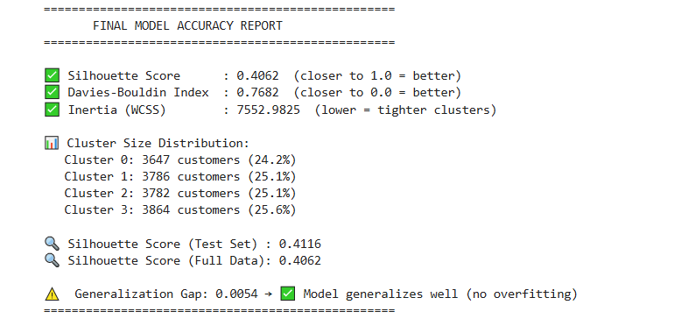
References.
[1] P. Kotler and G. Armstrong, Principles of Marketing, 17th ed. Pearson, 2018.
[2] J. MacQueen, "Some methods for classification and analysis of multivariate observations," in Proc. 5th Berkeley Symp. on Mathematical Statistics and Probability, 1967, pp. 281–297.
[3] V. Kumar and W. Reinartz, Customer Relationship Management, 3rd ed. Springer, 2018.
[4] R. L. Thorndike, "Who belongs in the family?" Psychometrika, vol. 18, no. 4, pp. 267–276, Dec. 1953.
[5] R. Tibshirani, G. Walther, and T. Hastie, "Estimating the number of clusters in a data set via the gap statistic," J. R. Stat. Soc. B, vol. 63, no. 2, pp. 411–423, 2001.
[6] P. J. Rousseeuw, "Silhouettes: A graphical aid to the interpretation and validation of cluster analysis," J. Comput. Appl. Math., vol. 20, pp. 53–65, 1987.
[7] D. Arthur and S. Vassilvitskii, "k-means++: The advantages of careful seeding," in Proc. 18th ACM-SIAM Symp. Discrete Algorithms, 2007, pp. 1027–1035.
[8] M. Ester, H.-P. Kriegel, J. Sander, and X. Xu, "A density-based algorithm for discovering clusters in large spatial databases with noise," in Proc. 2nd Int. Conf. Knowledge Discovery and Data Mining, 1996, pp. 226–231.
[9] C. M. Bishop, Pattern Recognition and Machine Learning. Springer, 2006.
[10] H. Hwang, T. Jung, and E. Suh, "An LTV model and customer segmentation based on customer value," Expert Syst. Appl., vol. 26, no. 2, pp. 181–188, 2004.
[11] Kaggle, "Mall Customer Segmentation Data," [Online]. Available: https://www.kaggle.com/datasets/vjchoudhary7/customer-segmentation-tutorial-in-python. [Accessed: May 2026].

